LAB REPORT 2

Pertemuan 2. Motor DC – Driver Motor

Nama : Achmad Fadli

NIM : 20/462070/PA/20042

Tanggal : 06/09/2021

Asisten : Rizki Fajar Kurniawan

1. **Transistor dan Motor DC**

|  |  |  |  |
| --- | --- | --- | --- |
| No | Tegangan (V) | Arus (A) | Arah |
| 1. | 11.8 | 0.09 | cw |
| 2. | 11.7 | 0.20 | cw |
| 3. | 11.6 | 0.29 | cw |
| 4. | 11.5 | 0.38 | cw |
| 5. | 11.4 | 0.47 | cw |
| 6. | 11.3 | 0.56 | cw |
| 7. | 11.2 | 0.65 | cw |
| 8. | 11.1 | 0.74 | cw |
| 9. | 11.0 | 0.82 | cw |
| 10. | 10.9 | 0.91 | cw |

Grafik Tegangan (V) vs Arus (A)

Skematik

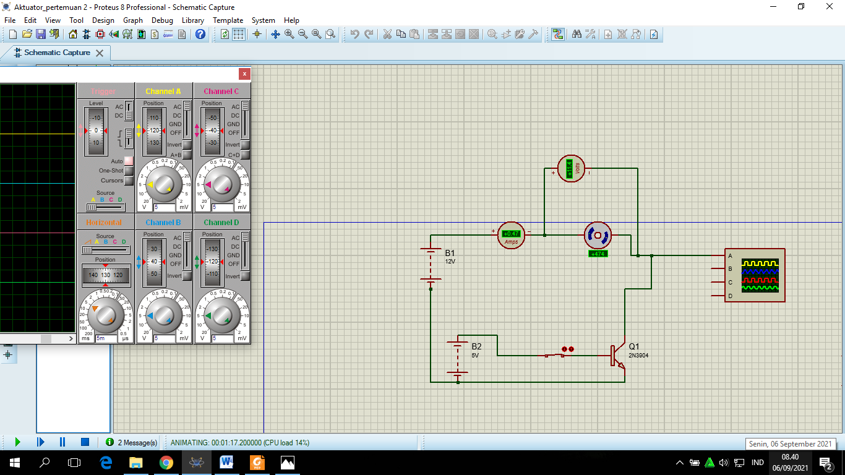

Bentuk sinyal saat motor dinyalakan



mendatar

1. **Arah Gerak Motor**

| No | L0 | L1 | Arah |
| --- | --- | --- | --- |
| 1. | 0 | 0 | diam |
| 2. | 0 | 1 | cw |
| 3. | 1 | 0 | ccw |
| 4. | 1 | 1 | diam |

|  |  |  |  |
| --- | --- | --- | --- |
| No | Tegangan (V) | Arus (A) | Arah |
| 1. |  |  |  |
| 2. |  |  |  |
| 3. |  |  |  |
| 4. |  |  |  |
| 5. |  |  |  |
| 6. |  |  |  |
| 7. |  |  |  |
| 8. |  |  |  |
| 9. |  |  |  |
| 10. |  |  |  |

Skematik

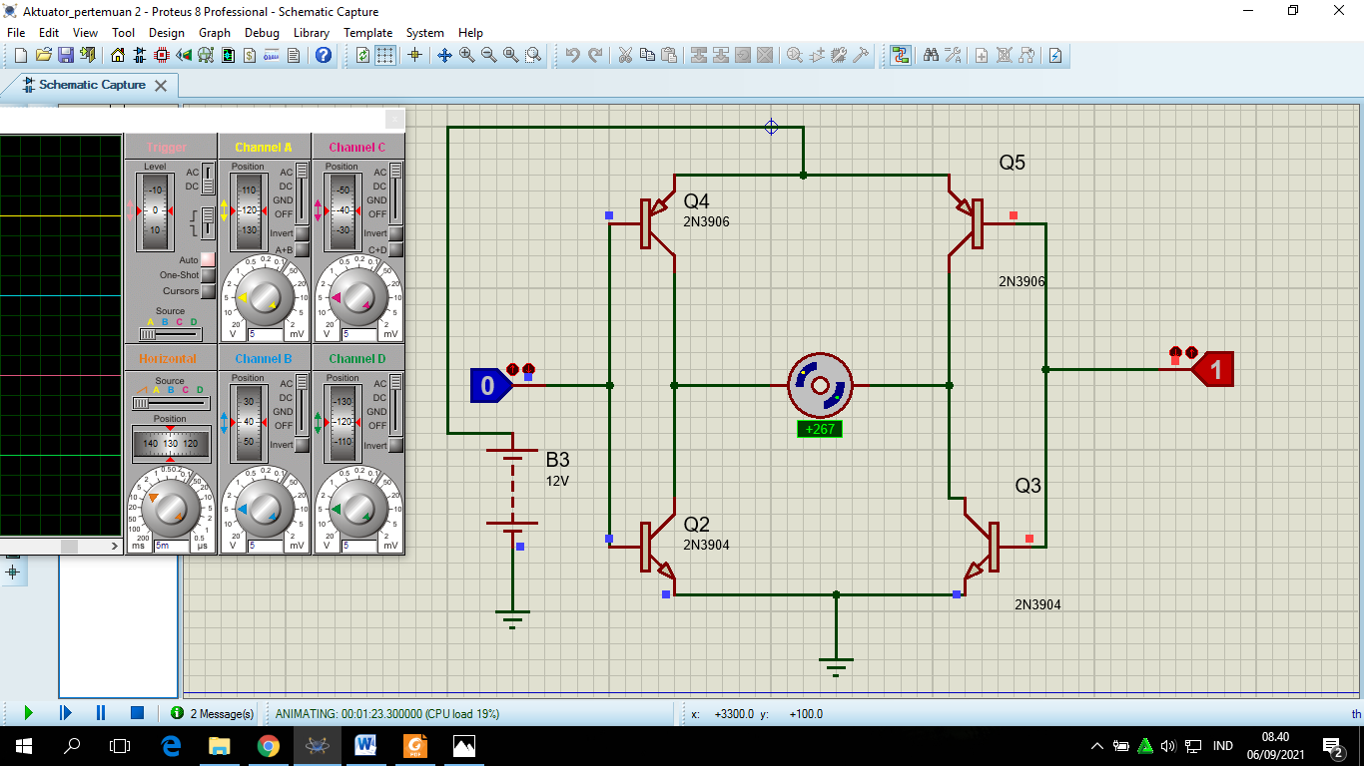

1. **Merangkai IC Driver Motor**

| No | E1 | I1 | I2 | O1 | O2 | Arah |
| --- | --- | --- | --- | --- | --- | --- |
| 1. | 0 | 0 | 0 |  |  |  |
| 2. | 0 | 0 | 1 |  |  |  |
| 3. | 0 | 1 | 0 |  |  |  |
| 4. | 0 | 1 | 1 |  |  |  |
| 5. | 1 | 0 | 0 |  |  |  |
| 6. | 1 | 0 | 1 |  |  |  |
| 7. | 1 | 1 | 0 |  |  |  |
| 8. | 1 | 1 | 1 |  |  |  |

|  |  |  |  |
| --- | --- | --- | --- |
| No | Tegangan (V) | Arus (A) | Arah |
| 1. |  |  |  |
| 2. |  |  |  |
| 3. |  |  |  |
| 4. |  |  |  |
| 5. |  |  |  |
| 6. |  |  |  |
| 7. |  |  |  |
| 8. |  |  |  |
| 9. |  |  |  |
| 10. |  |  |  |

Bentuk Sinyal saat Motor dinyalakan

Bentuk sinyal sat diberi hambatan

1. **Tugas**

| No | E1 | I1 | I2 | O1 | O2 | Arah |
| --- | --- | --- | --- | --- | --- | --- |
| 1. | 0 | 0 | 0 |  |  |  |
| 2. | 0 | 0 | 1 |  |  |  |
| 3. | 0 | 1 | 0 |  |  |  |
| 4. | 0 | 1 | 1 |  |  |  |
| 5. | 1 | 0 | 0 |  |  |  |
| 6. | 1 | 0 | 1 |  |  |  |
| 7. | 1 | 1 | 0 |  |  |  |
| 8. | 1 | 1 | 1 |  |  |  |

1. **Pertanyaan**
2. Apa bedanya menggunakan transistor dan tanpa transistor?
3. Bagaimana cara kerja H Bridge mengatur arah gerak motor?
4. Bagaimana bentuk sinyal tegangan motor saat terhubung ke driver
5. Apa itu enable? Kenapa diperlukan?
6. Apa pengaruh penggunaan 1 motor dan 2 motor pada driver l293D?